**Interfacing Seven Segment Display with MSP430 MCU**



**Spring 2025**

Submitted by: **Mohsin Sajjad**

Registration No: **22pwsce2149**

Class Section: **A**

“On my honor, as student of University of Engineering and Technology, I have neither given nor received unauthorized assistance on this academic work.”



Student Signature: ______________

Submitted to:

**Engr. Faheem Jan**

Month Day, Year (02 03, 2025)

Department of Computer Systems Engineering

University of Engineering and Technology, Peshawar

# LAB No 4

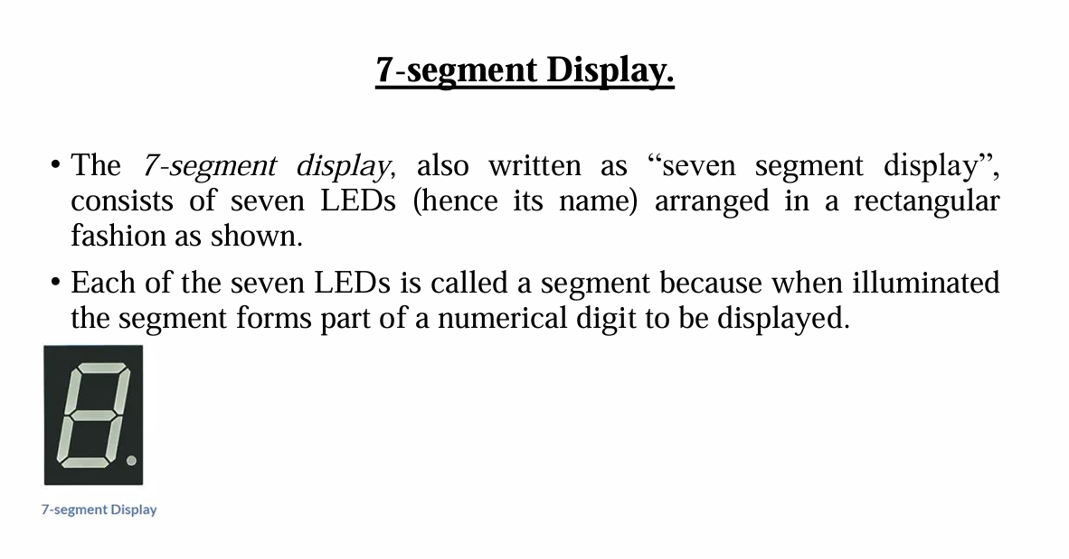

**Common Cathode:**

In a common cathode (CC) 7-segment display, all the cathodes of the LEDs are connected to ground (0V). To turn on a segment, you apply a HIGH (1) signal to the corresponding anode.

**Common Anode:**

In a **common anode (CA) 7-segment display**, all anodes are connected to **Vcc (power supply)**. To turn on a segment, you apply a **LOW (0)** signal to the corresponding cathode.

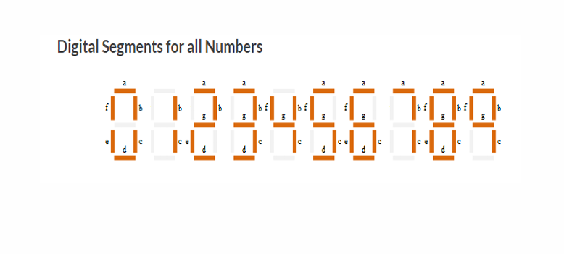

**TASKS:**

**TASK1:**

Run all the program given in the lecture.

**Display 1:**

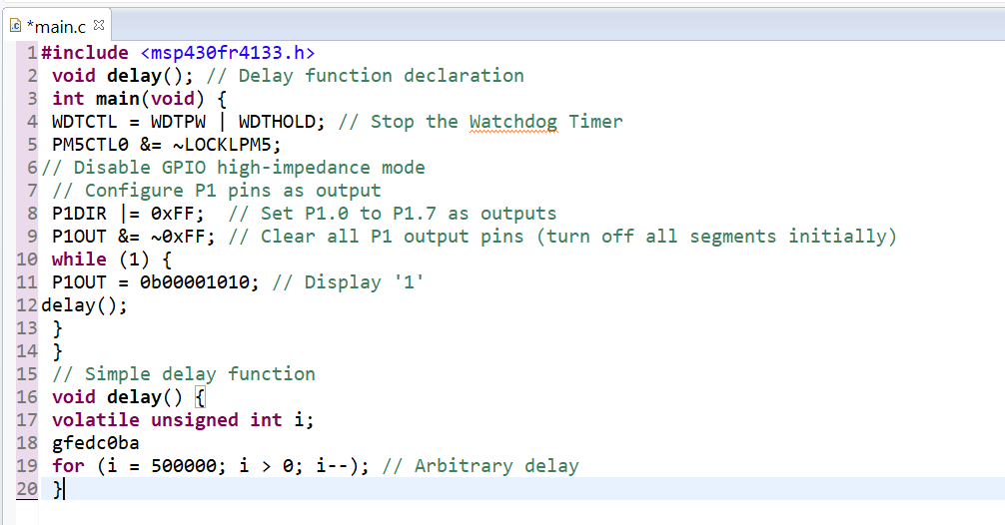

**Output:**

**Display 1 and 3:**

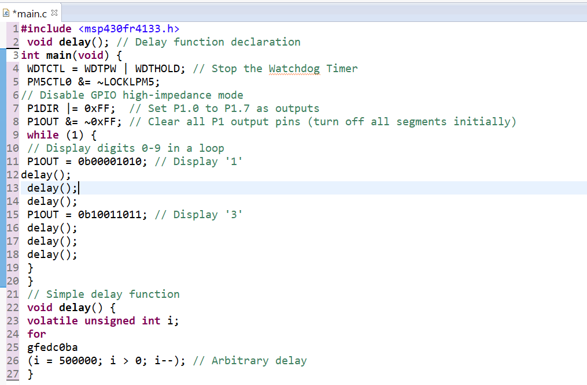

**Output:**

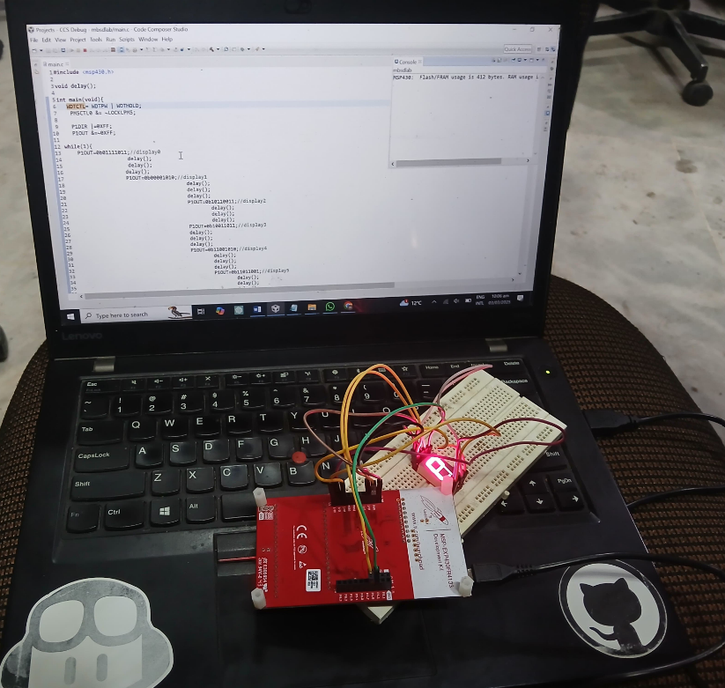

**Display 1 ,2 ,3 ,4:**

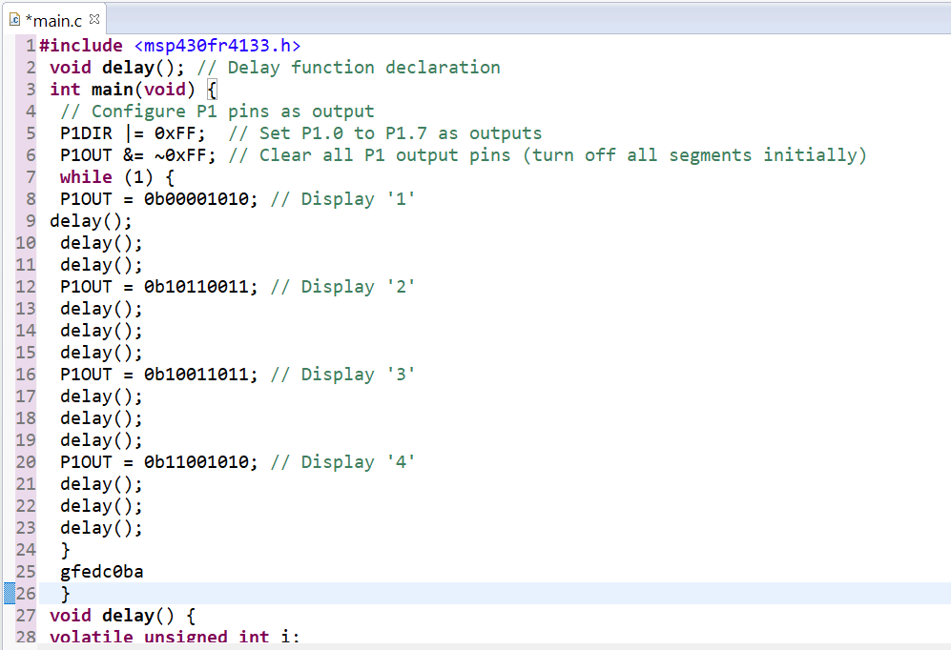

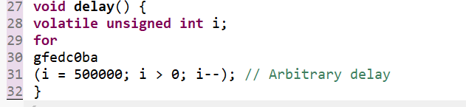  
**output:**



**Task 02:**

Display different digits on the Seven Segment Display.

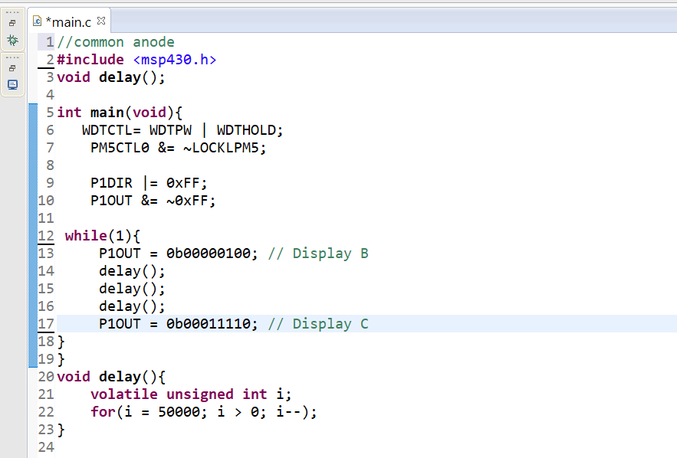

**Output:**



**Task 03:**

Display digits from 0 to F on Seven Segment Display.

Use Both Common Cathode and Common Anode Seven-Segment Display.

**Common Cathode:**

**Code:**

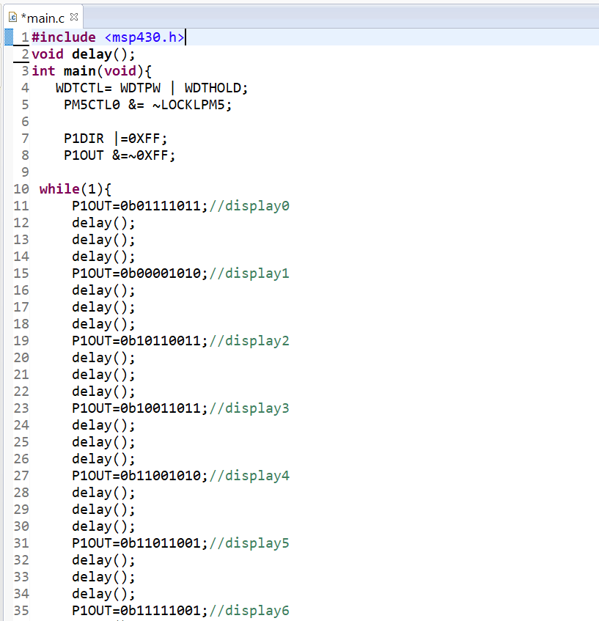

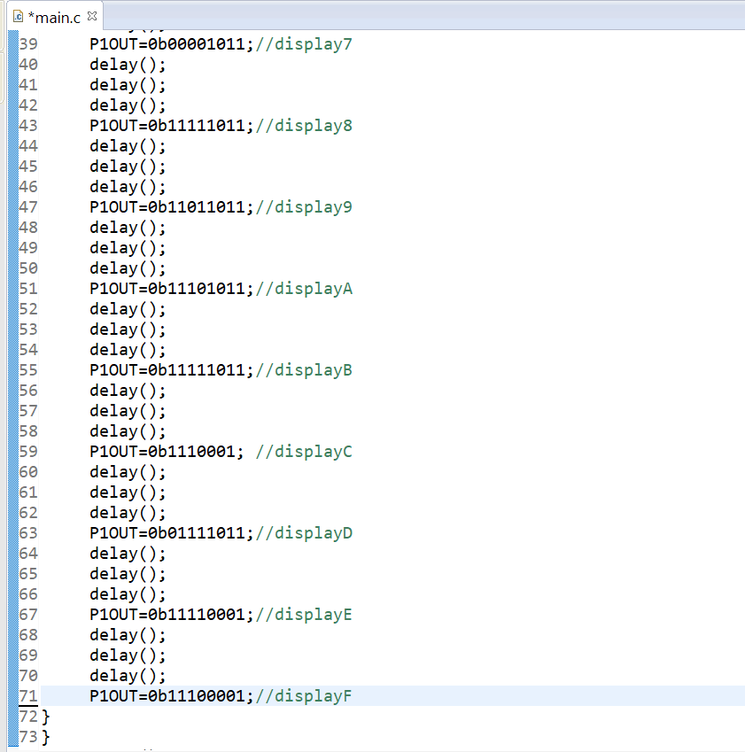

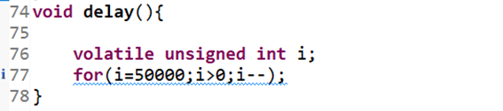

**Output:**

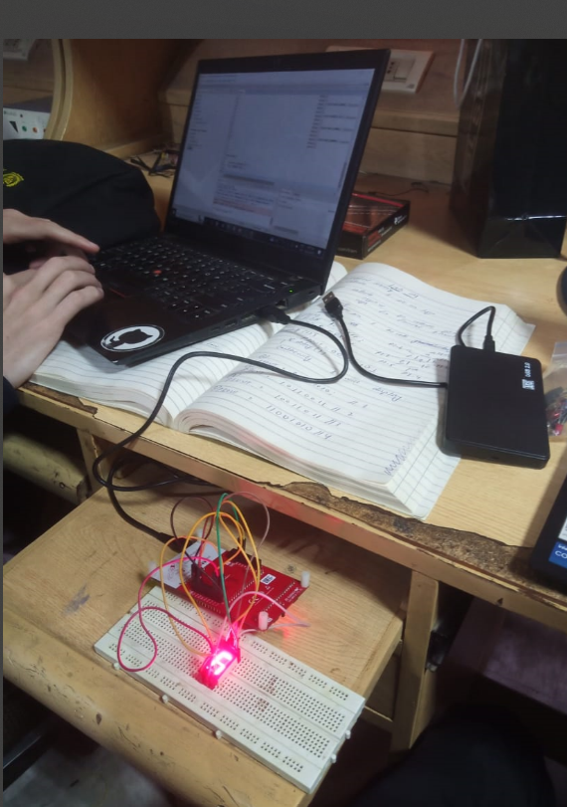

**Common Anode:**

**Code:**

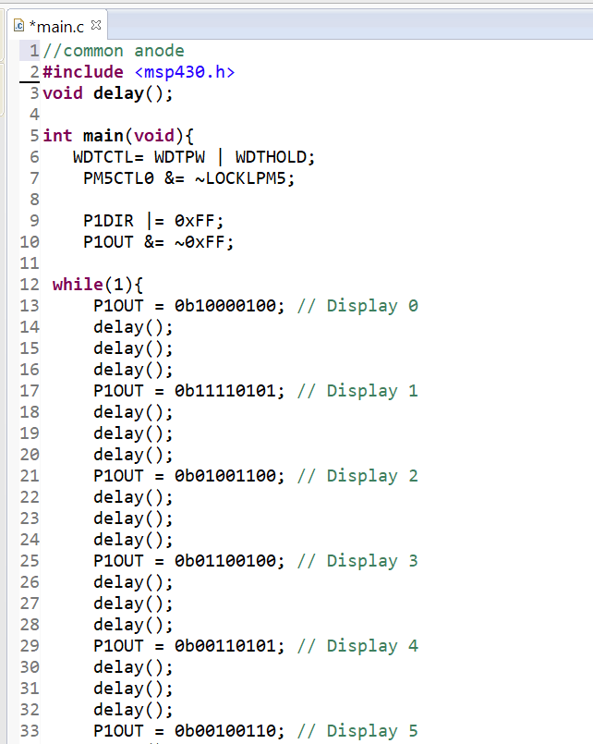

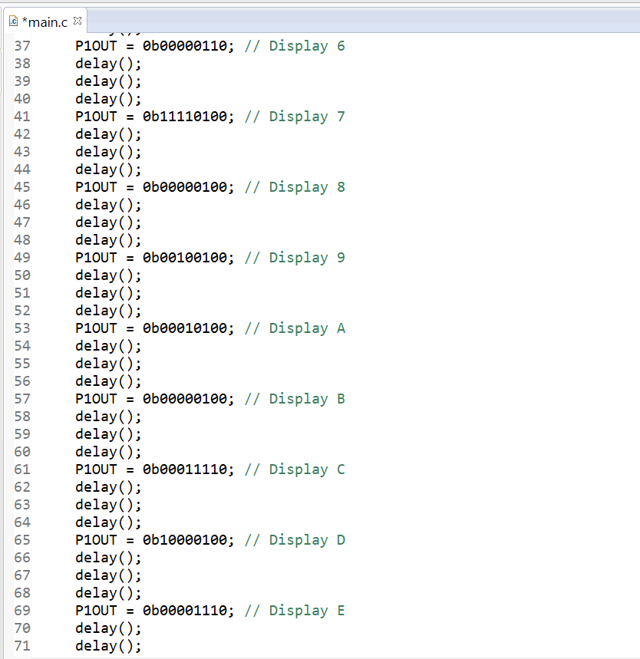

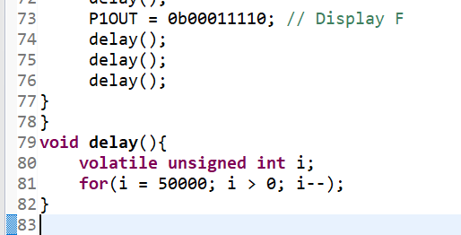

**OUTPUT:**

